**Types of Azure Clouds**

There are mainly three types of clouds in Microsoft Azure are:

1. PAAS
2. SAAS
3. IASS

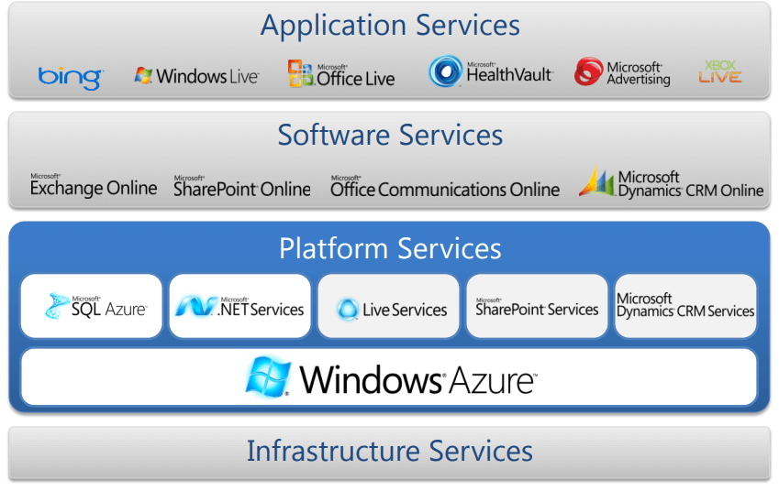

**Azure as IaaS**

IaaS(Infrastructure as a Service) is the foundational cloud platform layer. This Azure service is used by IT administrators for processing, storage, networks or any other fundamental computer operations. It is one of the Azure topics to learn that allows users to run arbitrary software.

**Advantages:**

* It offers efficient design time portability
* It is advisable for the application which needs complete control
* IaaS offers quick transition of services to clouds
* The apparent benefit of laaS is that it frees you from the concerns of setting up many physical or virtual machines.
* Helps you to access, monitor and manage datacenters

**Disadvantages of Iaas:**

* Plenty of security risks from unpatched servers
* Some companies have defined processes for testing and updating on-premise servers vulnerabilities. This cannot be done with Azure.

**Azure as PaaS**

PaaS is a computing platform which includes an operating system, programming language execution environment, database or web services. This Azure service is used by developers and application providers.

As its name suggests, this platform is provided to the client to develop and deploy software. It is one of the Azure basic concepts which allows the client to focus on application development instead of worrying about hardware and infrastructure. It also takes care of operating systems, networking and servers issues.

**Advantages:**

* The total cost is low as the resources are allocated on demand and servers are automatically added or subtracted.
* Azure is less vulnerable because servers are automatically checked for all known security issues
* The entire process is not visible to the developer, so it does not have a risk of a data breach

**Disadvantages:**

* Portability issues can occur when you use PaaS services
* There may be different environment at Azure, so the application needs to adapt accordingly.

**Azure As SaaS**

SaaS (Software as a Service) is software which is centrally hosted and managed. It is a single version of the application is used for all customers. You can scale out to multiple instances. This helps you to ensure the best performance in all locations. The software is licensed through a monthly or annual subscription. MS Exchange, Office, Dynamics are offered as a SaaS

**Azure key Concepts**

|  |  |
| --- | --- |
| **Concept Name** | **Description** |
| **Regions** | Azure is a global cloud platform which is available across various regions around the world. When you request a service, application, or VM in Azure, you are first asked to specify a region. The selected region represents datacenter where your application runs. |
| **Datacenter** | In Azure, you can deploy your applications into a variety of data centers around the globe. So, it is advisable to select a region which is closer to most of your customers. It helps you to reduce latency in network requests. |
| **Azure portal** | The Azure portal is a web-based application which can be used to create, manage and remove Azure resource and services. It is located at [https://portal.azure.com](https://portal.azure.com/). |
| **Resources** | Azure resource is an individual computer, networking data or app hosting services which charged individually. Some common resources are virtual machines( VM), storage account, or SQL databases. |
| **Resource groups** | An Azure resource group is a container which holds related resource for an Azure solution. It may include every resource or just resource which you wants to manage. |
| **Resource Manager templates** | It is a JSON which defines one or more resource to deploy to a resource group. It also establishes dependencies between deployed resources. |
| **Automation:** | Azure allows you to automate the process of creating, managing and deleting resource by using PowerShell or the Azure command-line Interface(CLI). |
| **Azure PowerShell** | PowerShell is a set of modules that offer cmdlets to manage Azure. In most cases, you are allowed to use, the cmdlets command for the same tasks which you are performing in the Azure portal. |
| **Azure command-line interface(CLI)** | The Azure CLI is a tool that you can use to create, manage, and remove Azure resources from the command line. |
| **REST APIs** | Azure is built on a set of REST APIs help you perform the same operation that you do in Azure portal Ul. It allows your Azure resources and apps to be manipulated via any third party software application. |

**Azure Domains (Components)**

Now in this Azure fundamentals tutorial, let’s learn the key Azure Components:

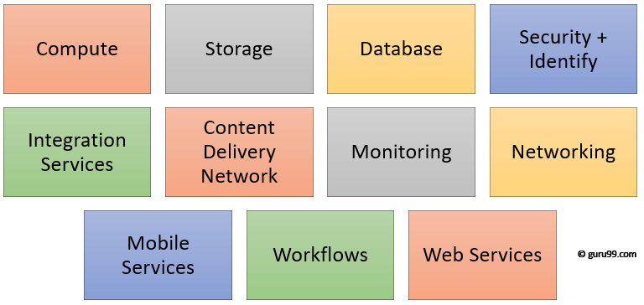

Key Azure Components

**Compute**

It offers computing operations like app hosting, development, and deployment in Azure Platform. It has the following components:

* Virtual Machine: Allows you to deploy any language, workload in any operating system
* Virtual Machine Scale Sets: Allows you to create thousands of similar virtual machines in minutes
* Azure Container Service: Create a container hosting solution which is optimized for Azure. You scale and arrange applications using Kube, DC/OS, Swarm or Docker
* Azure Container Registry: This service store and manage container images across all types of Azure deployments
* Functions: Let’s you write code regardless of infrastructure and provisioning of servers. In the situation when your functions call rate scales up.
* Batch: Batch processing helps you scale to tens, hundreds or thousands of virtual machines and execute computer pipelines.
* Service Fabric: Simplify microservice-based application development and lifecycle management. It supports Java, PHP, Node.js, Python, and Ruby.

**Storage**

Azure store is a cloud storage solution for modern applications. It is designed to meet the needs of their customer’s demand for scalability. It allows you to store and process hundreds of terabytes of data. It has the following components:

* Blob Storage: Azure Blob storage is a service which stores unstructured data in the cloud as objects/blobs. You can store any type of text or binary data, such as a document, media file, or application installer.
* Queue Storage: It provides cloud messaging between application components. It delivers asynchronous messaging to establish communication between application components.
* File Storage: Using Azure File storage, you can migrate legacy applications. It relies on file shares to Azure quickly and without costly rewrites.
* Table Storage: Azure Table storage stores semi-structured NoSQL data in the cloud. It provides a key/attribute store with a schema-less design

**Database**

This category includes Database as a Service (DBaaS) which offers SQL and NoSQL tools. It also includes databases like Azure Cosmos DB and Azure Database for PostgreSQL. It has the following components:

* SQL Database: It is a relational database service in the Microsoft cloud based on the market-leading Microsoft SQL Server engine.
* DocumentDB: It is a fully managed NoSQL database service which is It built for fast and predictable performance and ease of development.
* Redis Cache: It is a secure and highly advanced key-value store. It stores data structures like strings, hashes, lists, etc.

**Content Delivery Network**

Content Delivery Network (CDN) caches static web content at strategically placed locations. This helps you to offer speed for delivering content to users. It has the following components:

* VPN Gateway: VPN Gateway sends encrypted traffic across a public connection.
* Traffic Manager: It helps you to control and allows you to do the distribution of user traffic for services like WebApps, VM, Azure, and cloud services in different Datacenters
* Express Route: Helps you to extend your on-premises networks into the Microsoft cloud over a dedicated private connection to Microsoft Azure, Office 365, and CRM Online.

**Security + Identify sevices**

It provides capabilities to identify and respond to cloud [security threats](https://www.guru99.com/potential-security-threats-to-your-computer-systems.html). It also helps you to manage encryption keys and other sensitive assets. It has the following components:

* Key Vault: Azure Key Vault allows you to safeguard cryptographic keys and helps you to create secrets used by cloud applications and services.
* Azure Active Directory: Azure Active Directory and identity management service. This includes multi-factor authentication, device registration, etc.
* Azure AD B2C: Azure AD B2C is a cloud identity management solution for your consumer-facing web and mobile applications. It allows you to scales hundreds of millions of consumer identities.

**Enterprise Integration Services:**

* Service Bus: Service Bus is an information delivery service which works on the third-party communication system.
* SQL Server Stretch Database: This service helps you migrates any cold data securely and transparently to the Microsoft Azure cloud
* Azure AD Domain Services: It offers managed domain services like domain join, group policy, LDAP, etc. This authentication which is compatible with Windows Server Active Directory.
* Multi-Factor Authentication: Azure Multi-Factor Authentication (MFA) is two-step verification. It helps you to access data and applications to offers a simple sign-in process.

**Monitoring + Management Services**

These services allow easy management of Azure deployment.

* Azure Resource Manager: It makes it easy for you to manage and visualize resource in your app. You can even control who is your organization can act on the resources.
* Automation: Microsoft Azure Automation is a way to automate the manual, long-running, error-free, and constantly repeated tasks. These tasks are commonly performed in a cloud and enterprise environment.

**Azure Networking**

* Virtual Network: Perform Network isolation and segmentation. It offers filter and Route network traffic.
* Load Balancer: Offers high availability and network performance of any application. Load balance information Internet traffic to Virtual machines.
* Application Gateway: It is a dedicated virtual appliance that offers an Application Delivery Controller (ADC) as a service.
* Azure DNS: Azure DNS hosting service offers name resolution using Microsoft Azure infrastructure.

**Web and Mobile Services:**

* Web Apps: Web Apps allows you to build and host websites in the programming language of your choice without the need to manage its infrastructure.
* Mobile Apps: Mobile Apps Service offers a highly scalable, globally available mobile app development platform for users.
* API Apps: API apps make it easier to develop, host and consume APIs in the cloud and on-premises.
* Logic Apps: Logic Apps helps you to simplify and implement scalable integrations

**Workflows in the cloud**

It provides a visual designer to create and automate your process as a series of steps known as a workflow

* Notification Hubs: Azure Notification Hubs offers an easy-to-use, multi-platform, scaled-out push engine
* Event Hubs: Azure Event Hubs is data streaming platform which can manage millions of events per second. Data sent to an event hub can be transformed and stored using any real-time analytics offers batching/storage adapters.
* Azure Search: It is a cloud search-as-a-service solution which offers server and infrastructure management. It offers ready-to-use service that you can populate with your data. This can be used to add search to your web or mobile application.

**Migration**

Migration tools help an organization estimate workload migration costs. It also helps to perform the migration of workloads from your local data centers to the Azure cloud.

**Traditional vs. Azure Cloud Model**

Now in this Azure cloud tutorial, let’s learn about difference between Traditional cloud model vs Azure cloud model:

|  |  |
| --- | --- |
| **Traditional** | **Azure Cloud Model** |
| Dedicated infrastructure for each application | Loosely coupled apps and micro-services |
| Purpose-built hardware | Industry-standard hardware |
| Distinct infrastructure and operations teams | Service-focused DevOps teams |
| Customized processes & configurations | Standardized processes & configurations |